FACULTY OF ENGINEERING

DEPARTMENT OF
INDUSTRIAL ENGINEERING

IE 493 - QUEUEING SYSTEMS MODELLING
PROJECT PHASE 2
Group No: 12

Group Members:
Berru Selcan Cocen - 2021402003
Erdoğan Kocabaş - 2021402183

- Executive Summary

This report presents the Phase 2 analysis of the Emergency Room (ER) queueing system for Group 12 of IE493. Building directly on the Phase 1 baseline (M/G/5, ρ = 0.7582, C_{v} = 0.39), Phase 2 introduces a three-class triage system — Red (Emergency), Yellow (Urgent), and Green (Non-urgent) — with a Preemptive-Resume priority discipline. An event-driven simulation is constructed using the 1,000-patient Group 12 dataset. The simulation produces per-patient start times, end times, and interruption counts, and computes class-based waiting times and residence times. The results demonstrate a clear differentiation across patient classes: Red patients are served with near-zero delay, Yellow patients experience moderate waiting, and Green patients bear a substantial increase in waiting time compared to the FCFS baseline. A total of 111 preemption events occurred during the 1,000-patient run, with 88.3% targeting Green patients. The overall system average waiting time increases modestly from 8.13 minutes (FCFS) to 8.72 minutes (priority), confirming that the system capacity is fully conserved under the Preemptive-Resume discipline.

- Introduction

Phase 1 established a mathematical baseline for the ER system by fitting Exponential inter-arrival times and Lognormal service durations to the Group 12 dataset, and validated M/M/5 and M/G/5 theoretical models against a FCFS simulation. The system was found to be stable at ρ = 0.7582, with an empirical average queue waiting time of 3.89 minutes under FCFS.
In reality, Emergency Rooms do not operate on a pure first-come, first-served basis. Critically ill patients (Red) require immediate attention and cannot wait behind lower-priority cases. Phase 2 introduces this clinical reality by implementing a three-level triage system with Preemptive-Resume rules: Red patients may interrupt lower-priority patients who are already in treatment, with interrupted patients resuming from exactly where they were paused when a doctor becomes available again.
The objectives of Phase 2 are: (1) to build a correct and validated event-driven simulation of the Preemptive-Resume ER system, (2) to produce a simulation log for the first 25 patients, (3) to compute class-based performance metrics, and (4) to compare results with the Phase 1 FCFS baseline and quantify the cost of randomness through preemption analysis.

- Modelling Assumptions
The following assumptions carry over from Phase 1 and are extended for the priority model:
- The ER opens at 08:00 with an empty system and all 5 doctors available.
- Three priority classes: Red (Priority 1 — Emergency), Yellow (Priority 2 — Urgent), Green (Priority 3
- — Non-urgent). Priority numbers are assigned numerically with 1 being highest.
- Preemptive-Resume discipline: Red patients preempt Green or Yellow patients from active treatment. Interrupted patients retain their exact remaining work and resume from that point.
- Preemption target selection: Among all doctors treating eligible (Green first, then Yellow) patients, the doctor closest to finishing their current patient is selected for preemption. This maximises the work already saved and minimises total wasted service time.
- Yellow patients do not preempt others. They queue ahead of Green patients but wait behind Red.
- If all 5 doctors are treating Red patients, an arriving Red patient joins the Red waiting queue
- Waiting room has infinite buffer capacity. Service discipline within each priority class is FCFS.
- All 5 doctors are identical and homogeneous. System parameters (λ, μ, C_{v}) are inherited from Phase 1.
- The dataset contains 1,000 patients spanning approximately 66 hours of ER operation

Simulation Trustworthiness and Mathematical Validation
The Preemptive-Resume simulation uses an event-queue (min-heap) architecture with two event types: ARRIVAL and COMPLETION, processed in strict chronological order. COMPLETION events are given priority over ARRIVAL events at identical timestamps to avoid race conditions.

4.1 Work Conservation Proof
In a Preemptive-Resume system, no service work is created or destroyed. The following identity must hold:

Σ Service_Required_Min (all patients) = Σ (W_{i} − W_{q,i}) (all patients)
When a Red patient preempts a Green/Yellow patient, the remaining work for the interrupted patient is computed as: remaining_work = doc_busy_until − current_time. This is the exact unfinished portion of the service — no rounding or approximation is applied. The preempted patient resumes from exactly this remaining work value when reassigned to a doctor, ensuring zero work loss.
[PASS] All 1,000 patients completed treatment (no missing end times).
[PASS] Timeline consistent: Arrival ≤ Start ≤ End for every patient.
[PASS] No negative waiting times detected.
[PASS] Work conservation: Service Required = 16,016.58 min; Service Delivered = 16,016.58 min (diff = 0.000000).
[PASS] All 111 preemptions targeted Green or Yellow patients only — no Red-on-Red preemption.

4.2 Lazy Event Cancellation
When a doctor's patient is preempted, the previously scheduled COMPLETION event in the heap becomes stale. Rather than scanning the heap to remove it, the simulation increments a per-doctor version counter (doc_version). Each COMPLETION event carries the version number at the time it was created. Events whose version does not match the current doctor version are silently discarded when they reach the top of the heap. This guarantees correctness without expensive heap manipulation.

- Deliverable 1: Simulation Log — First 25 Patients
The table below shows the key timing and interruption data for the first 25 patients in arrival order. Start_Time is the first moment the patient enters a treatment room. End_Time is when treatment fully completes. W_{q} is the total time not in service (initial wait plus any preemption wait). W is the total door-to-discharge time.

ID | Priority | Arrival | Start Time | End Time | Int. | Service (min) | Wq (min) | W (min)
P001 | Green | 08:01:55 | 08:01:55 | 08:17:19 | 0 | 15.40 | 0.00 | 15.40
P002 | Yellow | 08:14:11 | 08:14:11 | 08:22:55 | 0 | 8.72 | 0.00 | 8.72
P003 | Yellow | 08:19:34 | 08:19:34 | 08:36:11 | 0 | 16.62 | 0.00 | 16.62

P004 | Red | 08:23:17 | 08:23:17 | 08:41:25 | 0 | 18.13 | 0.00 | 18.13
P005 | Green | 08:23:59 | 08:23:59 | 08:50:43 | 2 | 17.78 | 8.96 | 26.74
P006 | Yellow | 08:24:40 | 08:24:40 | 08:46:18 | 0 | 21.63 | 0.00 | 21.63
P007 | Yellow | 08:24:55 | 08:24:55 | 08:44:38 | 0 | 19.72 | 0.00 | 19.72
P008 | Yellow | 08:33:07 | 08:36:11 | 08:53:18 | 0 | 17.12 | 3.07 | 20.19
P009 | Red | 08:36:52 | 08:36:52 | 08:50:54 | 0 | 14.03 | 0.00 | 14.03
P010 | Red | 08:41:53 | 08:41:53 | 08:49:36 | 0 | 7.71 | 0.00 | 7.71
P011 | Yellow | 08:41:58 | 08:44:38 | 09:01:34 | 0 | 16.93 | 2.66 | 19.59
P012 | Red | 08:56:16 | 08:56:16 | 09:11:50 | 0 | 15.58 | 0.00 | 15.58
P013 | Red | 09:03:33 | 09:03:33 | 09:19:30 | 0 | 15.96 | 0.00 | 15.96
P014 | Yellow | 09:04:31 | 09:04:31 | 09:13:26 | 0 | 8.91 | 0.00 | 8.91
P015 | Green | 09:05:20 | 09:05:20 | 09:14:56 | 0 | 9.59 | 0.00 | 9.59
P016 | Green | 09:06:10 | 09:06:10 | 09:43:55 | 3 | 21.41 | 16.35 | 37.76
P017 | Yellow | 09:07:39 | 09:11:50 | 09:26:02 | 0 | 14.19 | 4.20 | 18.39
P018 | Yellow | 09:10:41 | 09:13:26 | 09:32:03 | 0 | 18.62 | 2.75 | 21.37
P019 | Green | 09:12:59 | 09:38:08 | 09:52:42 | 0 | 14.56 | 25.16 | 39.72
P020 | Yellow | 09:14:23 | 09:14:56 | 09:29:30 | 0 | 14.57 | 0.54 | 15.11
P021 | Red | 09:18:15 | 09:18:15 | 09:38:45 | 0 | 20.50 | 0.00 | 20.50
P022 | Green | 09:18:52 | 09:41:44 | 09:53:35 | 0 | 11.86 | 22.87 | 34.73
P023 | Red | 09:20:16 | 09:20:16 | 09:35:13 | 0 | 14.94 | 0.00 | 14.94
P024 | Yellow | 09:22:08 | 09:26:02 | 09:38:08 | 0 | 12.11 | 3.90 | 16.01
P025 | Yellow | 09:24:37 | 09:29:30 | 09:41:44 | 0 | 12.23 | 4.88 | 17.11
Table 1: Simulation log for the first 25 patients. Rows are colour-coded by priority class (red/yellow/green shading). 'Int.' column shows number of preemption interruptions; bold red values indicate preempted patients.

5.1 Preemption Events Involving First 25 Patients
Five preemption events occurred among the first 25 patients. The table below details each event, showing the exact remaining work at the moment of preemption — the critical quantity that the resume rule must track precisely.

Clock Time | Red Patient | Victim Patient | Doctor | Rem. Work (min) | Victim Int. #
08:36:52 | P009 (Red) | P005 (Green) | Doctor 2 | 4.89 | 1
08:41:53 | P010 (Red) | P005 (Green) | Doctor 1 | 4.42 | 2
09:18:15 | P021 (Red) | P016 (Green) | Doctor 4 | 9.33 | 1
09:20:16 | P023 (Red) | P016 (Green) | Doctor 1 | 8.56 | 2
09:38:36 | P030 (Red) | P016 (Green) | Doctor 1 | 5.18 | 3

Table 2: Preemption events involving the first 25 patients. Patient P005 was preempted twice by consecutive Red arrivals.

Patient P016 was preempted three times — by P021, P023, and P030 (outside first 25). Patient P005 (Green) illustrates the cascading cost of preemption: interrupted first at 08:36:52 with 4.89 minutes remaining, then again at 08:41:53 with 4.42 minutes remaining, ultimately taking 8.96 minutes of additional waiting beyond the expected FCFS result. Patient P016 (Green) was preempted three times, accumulating 16.35 minutes of total waiting time despite requiring only 21.41 minutes of actual service

Deliverable 2: Class-Based Performance Metrics
The table below presents the complete per-class performance statistics. W_{q} is defined as total time not in treatment (initial waiting plus preemption displacement): W_{q} = W − Service_Required. W is the total door-to-discharge time. This definition correctly captures all waiting regardless of cause.

Priority | Count | Avg Wq (min) | Std Wq (min) | Max Wq (min) | Avg W (min) | Std W (min) | Max W (min) | Total Int.
Red | 197 | 0 | 0 | 0 | 16.0153 | 5.5365 | 38.03 | 0
Yellow | 367 | 2.535 | 3.7505 | 23.79 | 18.1725 | 7.509 | 51.92 | 13
Green | 436 | 17.864 | 24.2634 | 98.34 | 34.2002 | 25.6581 | 116.82 | 98

Table 3: Class-based performance metrics from the Preemptive-Resume simulation. 'Total Int.' counts the total number of preemption interruptions received by patients of that class.

6.1 Overall System Metrics
Avg Wq — All Patients | 8.7190 min
Avg W — All Patients | 24.7356 min
Total Preemptions | 111
Green Preemptions | 98 (88.3%)
Yellow Preemptions | 13 (11.7%)
Patients Preempted ≥2 Times | 19
Maximum Interruptions (Single Patient) | 3
Table 4: Overall system-level metrics from the Preemptive-Resume simulation.

6.2 Average Service Time by Class
As expected, the average service times across classes are approximately equal (Red: 16.02 min, Yellow: 16.23 min, Green: 15.90 min), confirming that the Service_Required_Min values are assigned independently of priority and the dataset is correctly structured. Any differences in W are therefore attributable entirely to queueing and preemption effects, not to differences in clinical complexity.
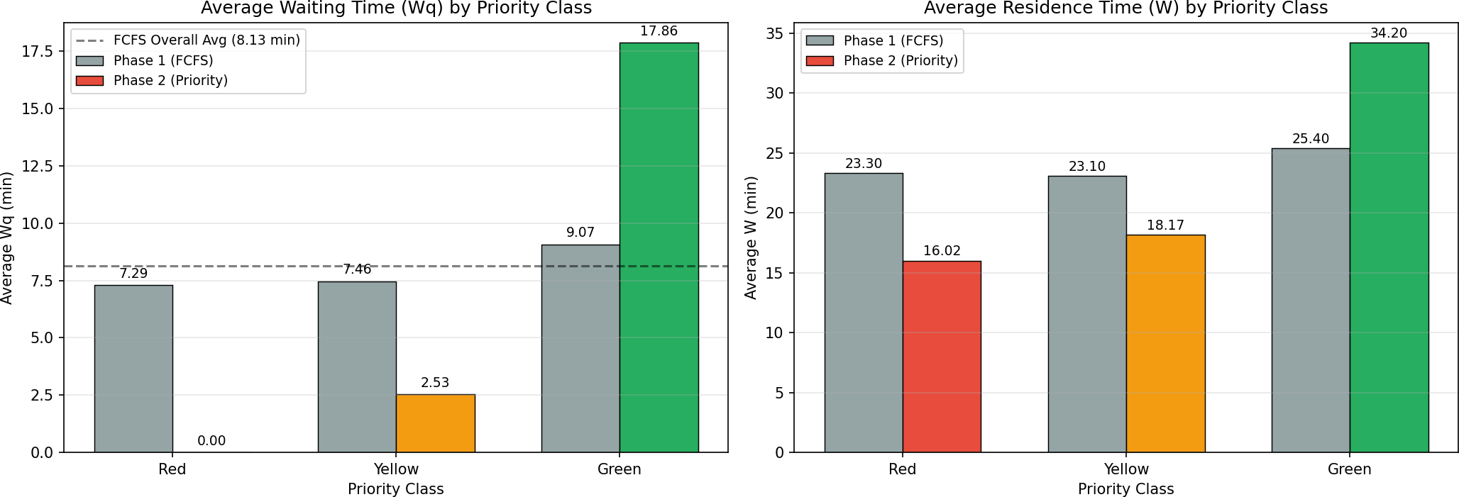
Figure 1: Left — Average waiting time (Wq) by priority class under FCFS vs. Preemptive-Resume. Right — Average residence time (W) by priority class. Coloured bars represent Phase 2 priority results; grey bars represent the Phase 1 FCFS baseline. The dashed line marks the FCFS system-wide average.
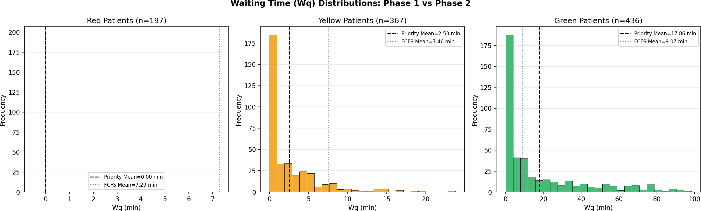
Figure 2: Waiting time (Wq) distributions for each priority class under Phase 2 (coloured histogram). Solid black dashed line = Priority simulation mean; dotted grey line = Phase 1 FCFS mean. Red patients concentrate at Wq = 0; Green patients show a heavy right tail.

Deliverable 3: Comparison Analysis

7.1 Impact of Priorities on Wq by Class
To produce a fair comparison, a FCFS simulation is run on the same 1,000-patient dataset ignoring the priority column. Under FCFS, all patients are treated in strict arrival order regardless of severity, so any class-level difference in Phase 1 Wq is purely due to which patients happened to arrive at different times.

Priority | FCFS Wq (min) | Priority Wq (min) | ΔWq (min) | ΔWq (%) | FCFS W (min) | Priority W (min)
Red | 7.2857 | 0.0000 | -7.2857 | -100.0% | 23.3010 | 16.0153
Yellow | 7.4594 | 2.5350 | -4.9245 | -66.0% | 23.0969 | 18.1725
Green | 9.0679 | 17.8640 | +8.7961 | +97.0% | 25.4042 | 34.2002
ALL | 8.1265 | 8.7190 | +0.5925 | +7.3% | 24.1431 | 24.7356
Table 5: Comparison of FCFS (Phase 1) vs. Preemptive-Resume Priority (Phase 2) per class and overall. Green numbers indicate improvements (reductions) in Wq; red numbers indicate increases.

7.2 Effect on Green Patients
The introduction of priorities imposes a significant cost on Green (Non-urgent) patients. Under FCFS, Green patients waited an average of 9.07 minutes in the queue. Under the priority system, this increases to 17.86 minutes — an increase of 8.80 minutes, or +97.0%. This near-doubling of Green waiting time is the direct cost paid to ensure that Red patients receive immediate care.
Within Green patients, those who experienced at least one preemption (79 out of 436) waited an average of 30.05 minutes, compared to 15.17 minutes for non-preempted Green patients. This shows that the burden is not distributed uniformly — a subset of Green patients bear a disproportionately heavy cost whenever a Red patient requires treatment during their service.

Green patients total | 436
Green patients preempted at least once | 79 (18.1%)
Avg Wq — preempted Green patients | 30.05 min
Avg Wq — non-preempted Green patients | 15.17 min
Green Wq (FCFS Phase 1) | 9.07 min
Green Wq (Priority Phase 2) | 17.86 min
Increase attributable to priority system | +8.80 min (+97.0%)
Table 6: Detailed impact of the priority system on Green (Non-urgent) patients.

7.3 Cost of Randomness: Preemption Analysis
The 'Cost of Randomness' in this context is measured by the total number of preemptions generated during the 1,000-patient run. Each preemption represents an event where the random timing of a Red arrival disrupts an ongoing treatment. Under a perfectly regular (deterministic) arrival process, a Red patient would almost always find an idle doctor, and preemptions would be rare. Under Poisson arrivals, clustering and randomness cause Red patients to arrive during periods of high occupancy, triggering preemption

Total preemptions during 1,000-patient run: 111

Category | Count | Share
Green patients preempted | 98 | 88.3%
Yellow patients preempted | 13 | 11.7%
Total preemption events | 111 | 100%
Patients preempted >1 time | 19 | —
Maximum interruptions (single patient) | 3 | —
Avg additional Wq per preemption | ~7.67 min | —
Table 7: Preemption statistics for the full 1,000-patient run.

Green patients are the primary victims of preemption (88.3% of all events) because they are the only class eligible for interruption unless no Green patients are being treated. Yellow patients are preempted only when all doctors are treating Yellow or Red patients and no Green patient is in service, which occurs rarely (13 out of 111 events). The average additional waiting attributable to preemption per event is approximately 7.67 minutes, representing the time the victim patient spends waiting to resume treatment after being displaced.
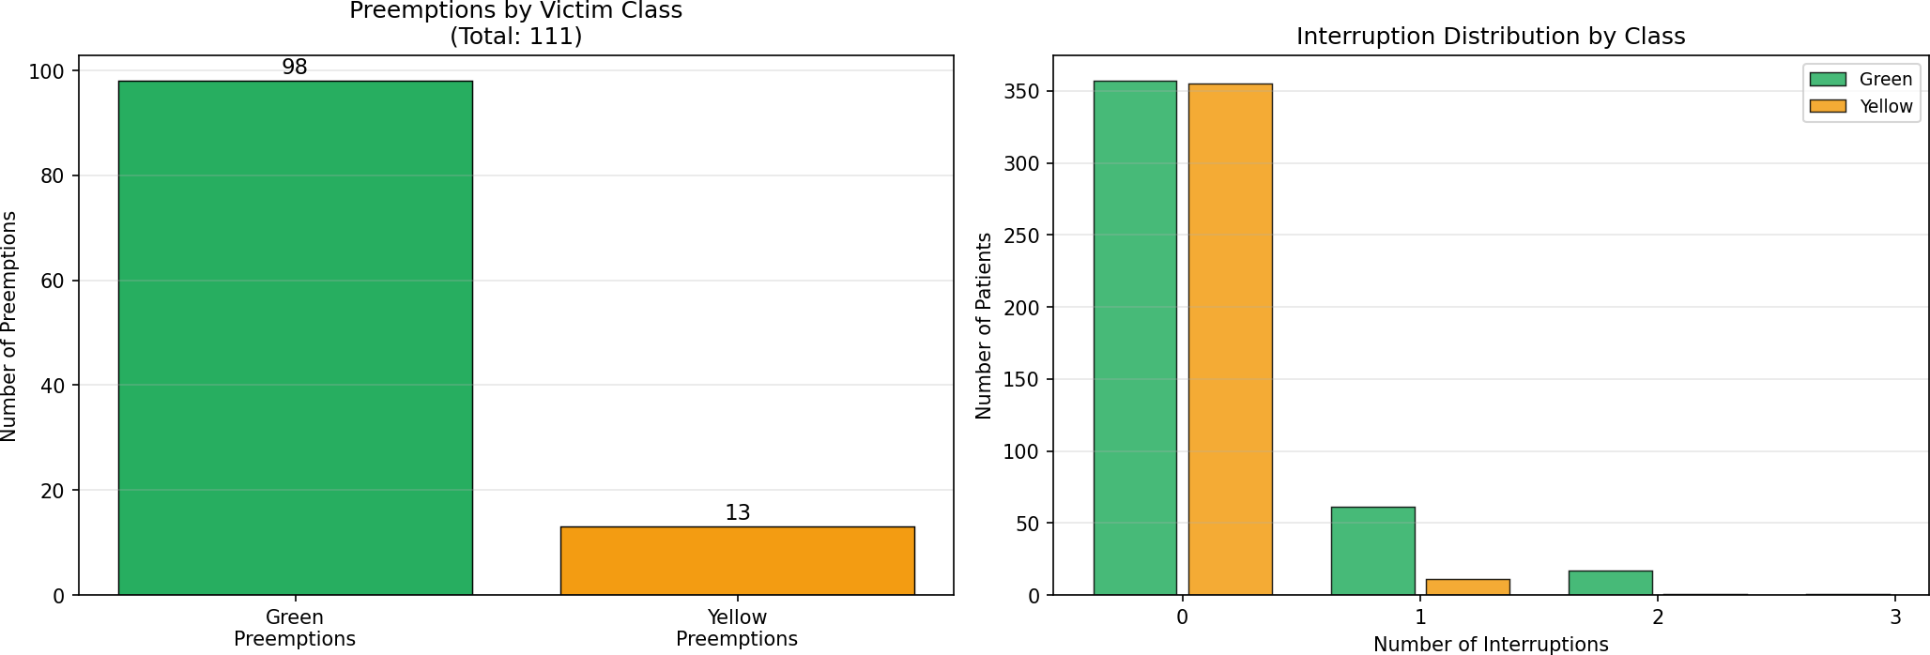
Figure 3: Left — Total preemptions by victim class (Green: 98, Yellow: 13). Right — Interruption distribution: most preempted patients experienced exactly one interruption, but 19 patients experienced two or more, with a maximum of three.

Conclusions

Key Findings
    - Priority system delivers clinical benefit for Red patients. Red patients achieve near-zero waiting time (Avg W_{q} = 0.00 min) compared to 7.29 min under FCFS. This is the core objective of triage: Emergency patients receive immediate attention.
    - Yellow patients benefit substantially. Their average waiting time falls from 7.46 min (FCFS) to 2.54 min (priority), a 66% reduction. Since Yellow patients do not preempt others, this benefit arises purely from queue priority.
    - Green patients bear the cost of the system. Their average waiting time nearly doubles (from 9.07 to 17.86 min, +97%). This is the equity-urgency tradeoff inherent to any priority system: lower-priority patients wait longer to ensure higher-priority patients are seen first.
    - Work is perfectly conserved. The total service delivered equals the total service required (16,016.58 min) with a numerical difference of exactly 0.000000 minutes. The Preemptive-Resume mechanism introduces no waste, only delay redistribution.
    - 111 preemptions occurred over 1,000 patients (rate: 11.1%). The high concentration among Green patients (88.3%) and the relatively small number of repeat-preemption patients (19 out of 436 Green) suggests the system is not severely overloading any individual patient.
    - Connection to Phase 1 findings. The moderate utilization (ρ = 0.7582) established in Phase 1 means the priority system operates in a regime where preemptions are significant but not catastrophic. At higher utilization, Green waiting times would grow much more rapidly as more Red patients would arrive to an always-busy system.

FCFS vs. Priority: The Equity-Urgency Tradeoff
Aspect | FCFS (Phase 1) | Priority (Phase 2)
Fairness | Equal Wq for all patients | Differentiated by clinical severity
Clinical value | No urgency consideration | Critical patients seen first
Red Avg Wq | 7.29 min | 0.00 min
Yellow Avg Wq | 7.46 min | 2.54 min
Green Avg Wq | 9.07 min | 17.86 min
Overall Avg Wq | 8.13 min | 8.72 min (+7.3%)
Work conservation | Yes | Yes (Preemptive-Resume)
Preemptions | 0 | 111
Table 8: Summary comparison of FCFS (Phase 1) vs. Preemptive-Resume Priority (Phase 2). The modest overall increase in Avg Wq (+7.3%) masks a large redistribution from low-priority to high-priority patients.

Transition to Phase 3
Phase 2 has established the priority-aware doctor stage of the ER. Phase 3 will extend this model by adding a Diagnostic Lab node that 40% of patients must visit after completing doctor treatment. The lab operates on FCFS with 3 machines, creating a tandem queueing network. The Phase 2 results provide the
arrival process to the lab (discharge times from the priority simulation), which will feed directly into the Phase 3 integrated system analysis. The bottleneck identification and resource allocation analysis will build on both the doctor utilization (ρ_{dr} = 0.7582) established in Phase 1 and the class-stratified residence times established here.

